Regional Fireside
Sponsored by the Single Adult Program

Dennis Williams
Presents

THE GREAT MEDIA ARCHIVES OF THE CHURCH

From 1840 –1900’s
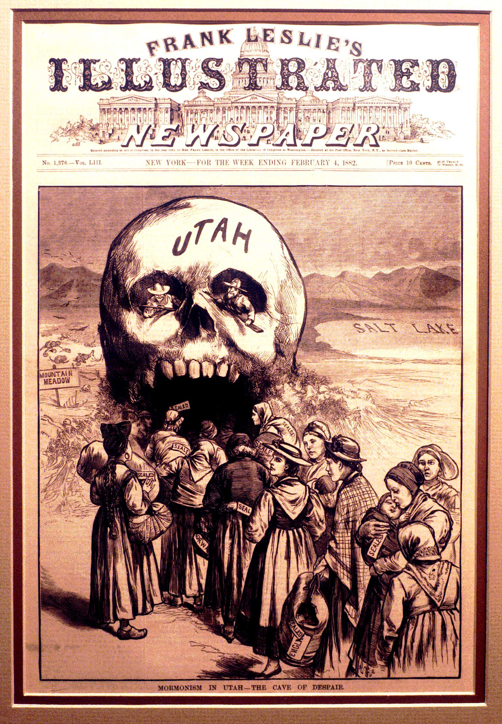

BY
An hour long
Incredible Power-point / slide presentation
You wont
Soon forget.
SPECIAL
REQUEST

.

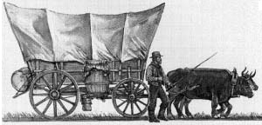

FACINATING
HISTORICAL
ENGRAVINGS
DISPLAYED

Sunday, August 28, 2005 7:00pm
Cochran Bldg, Simi Valley Ca
(5028 E Cochran St. (between Tapo St and Sterns Ave))

